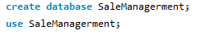
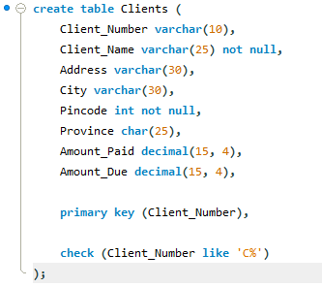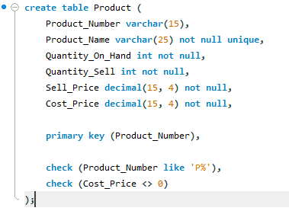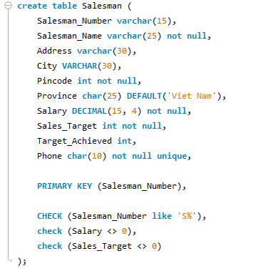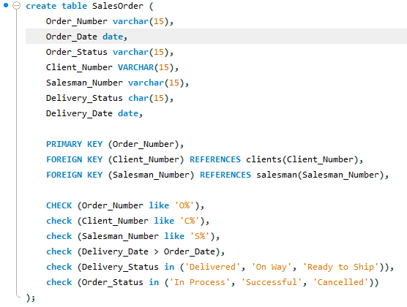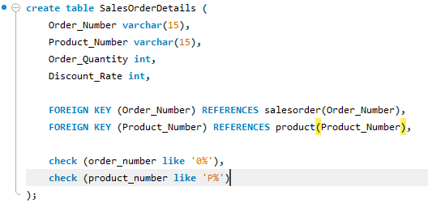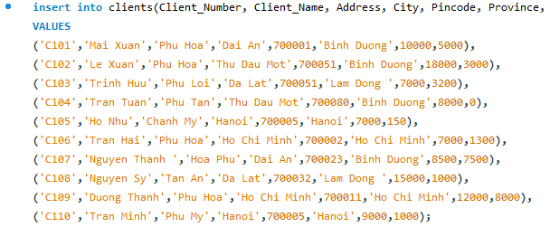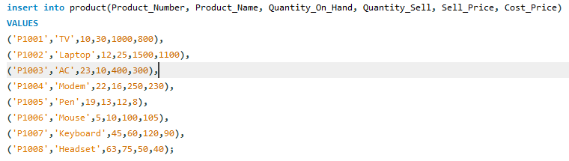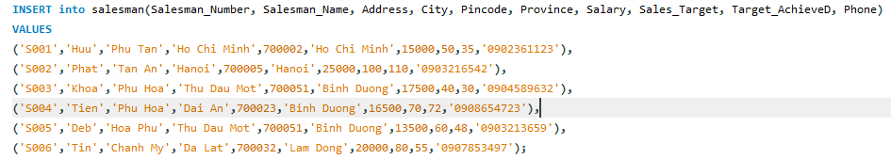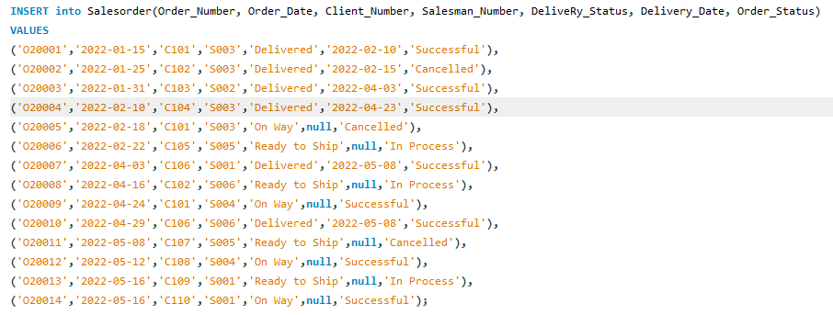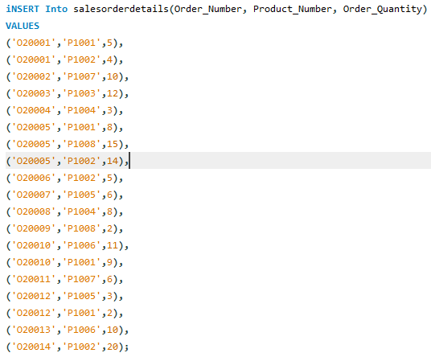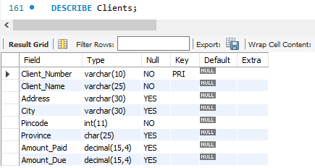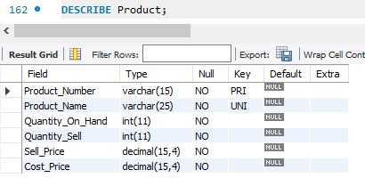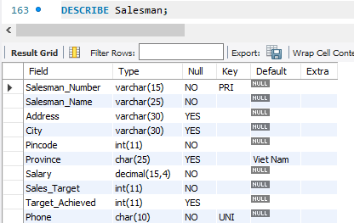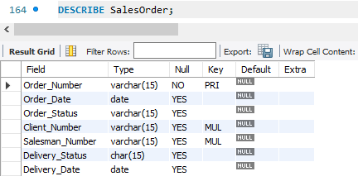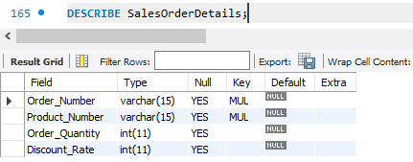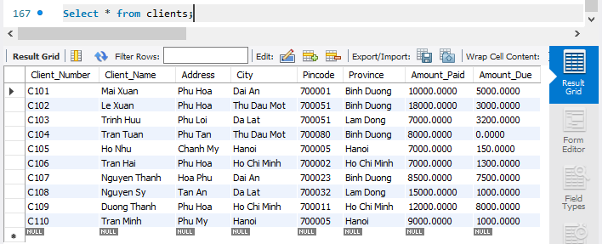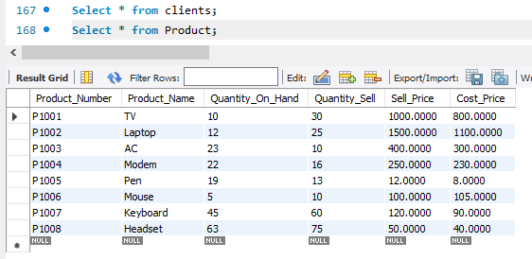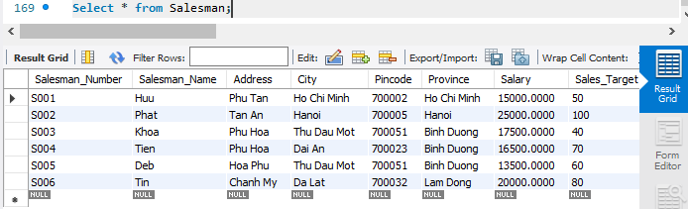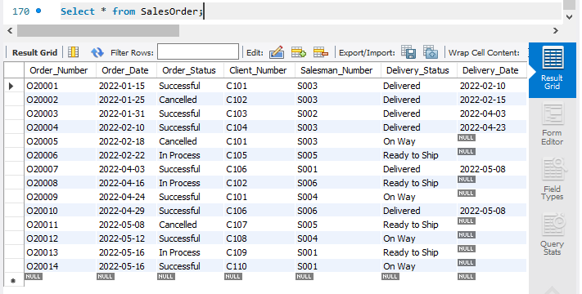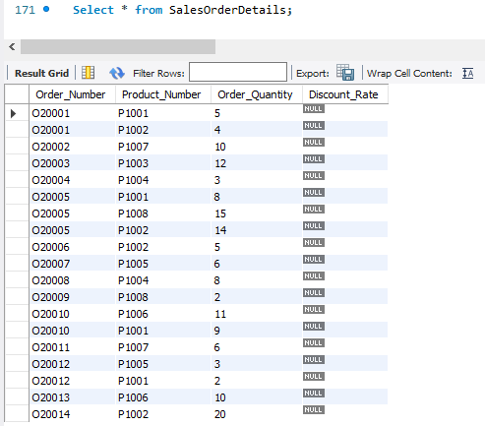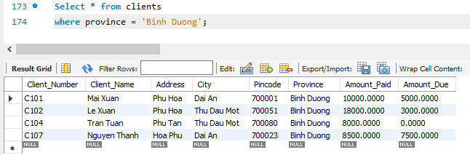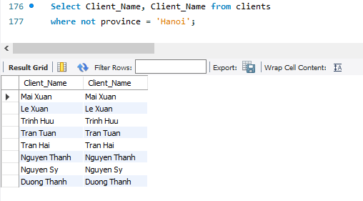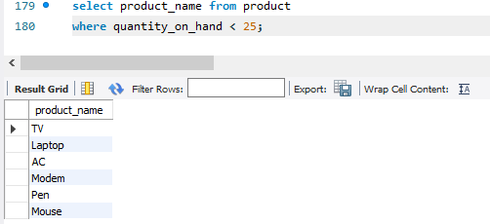
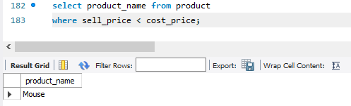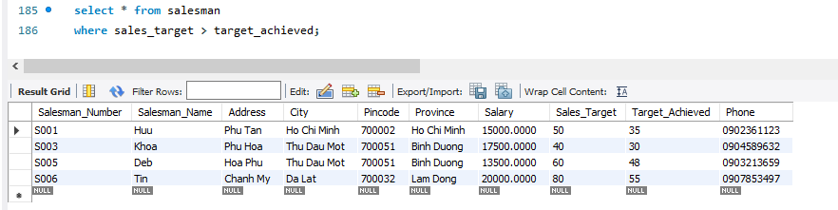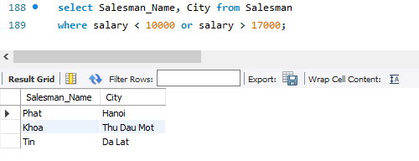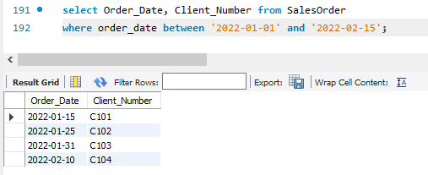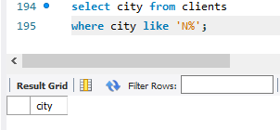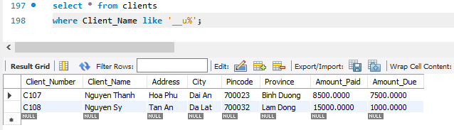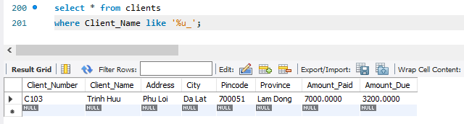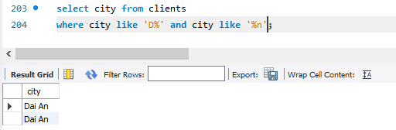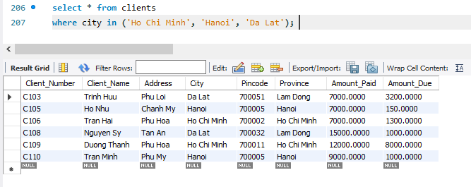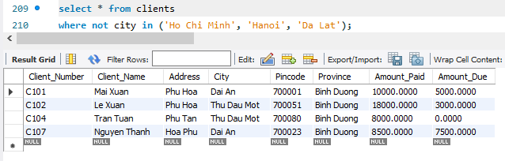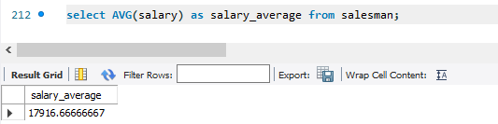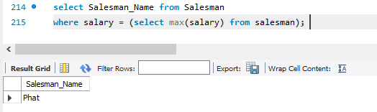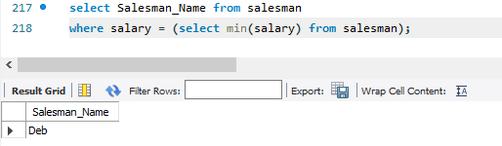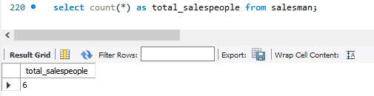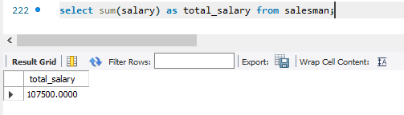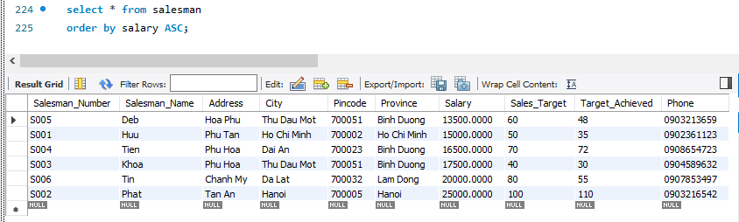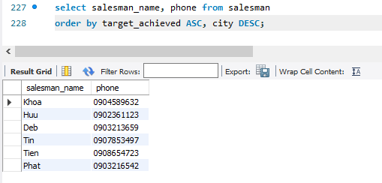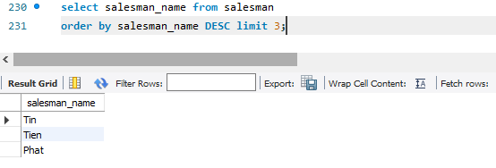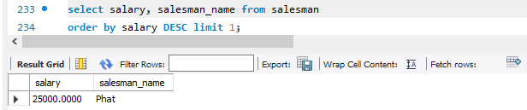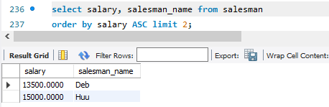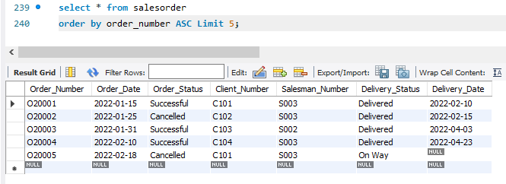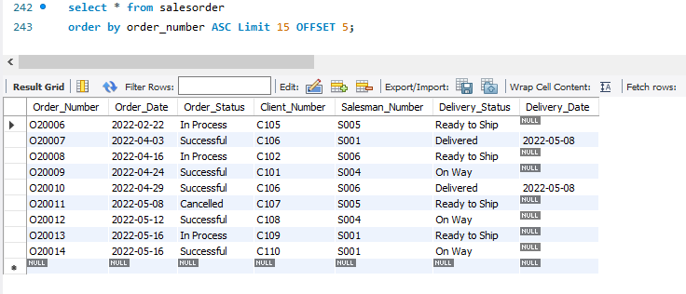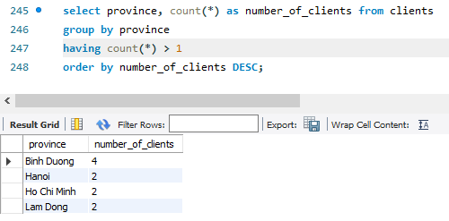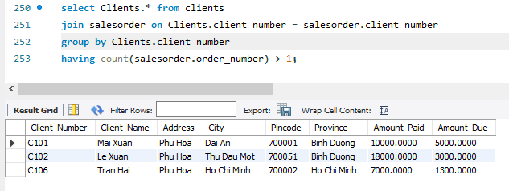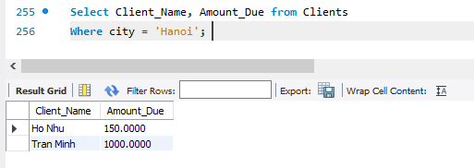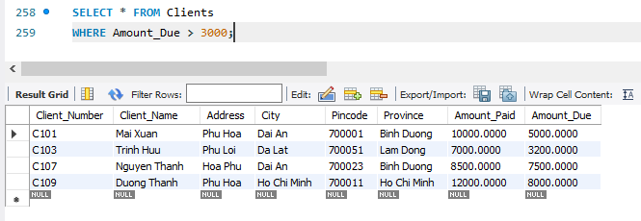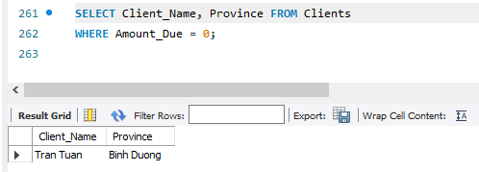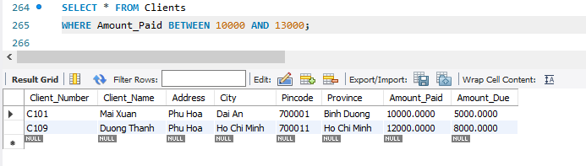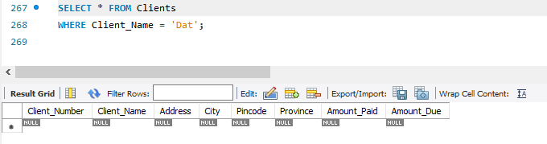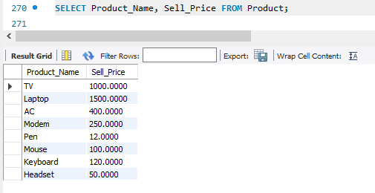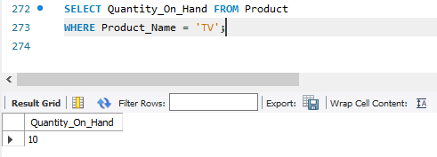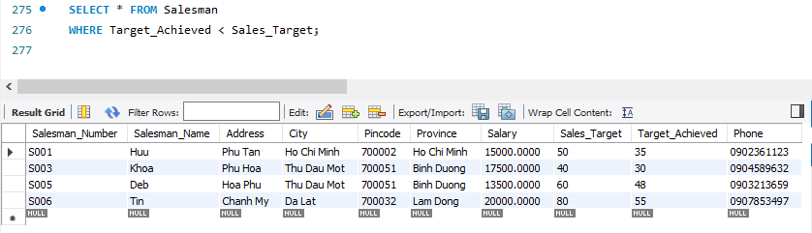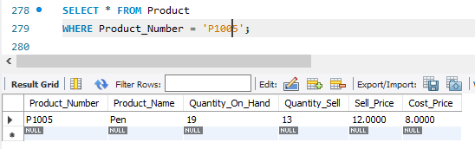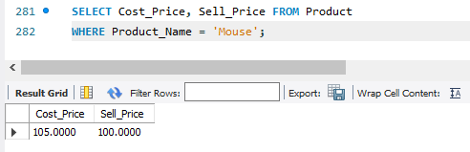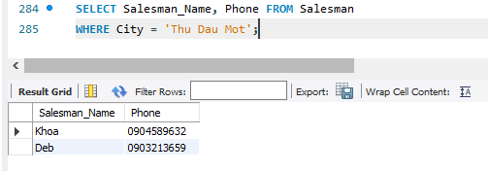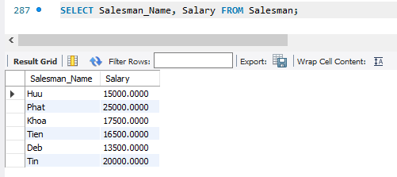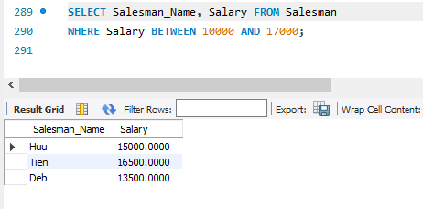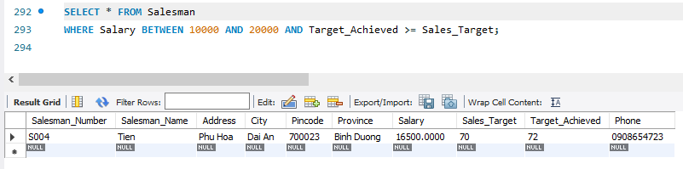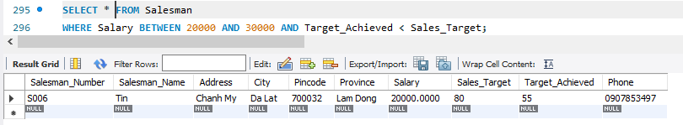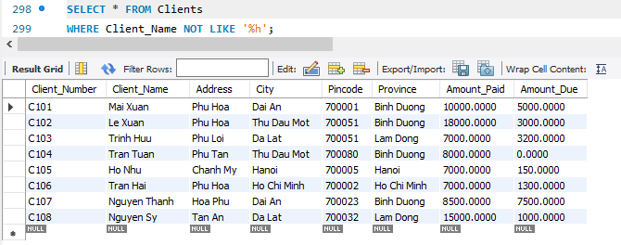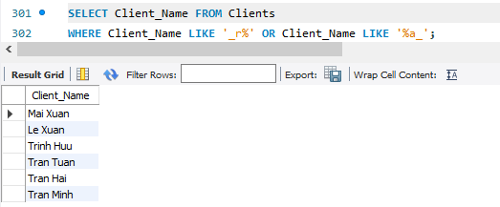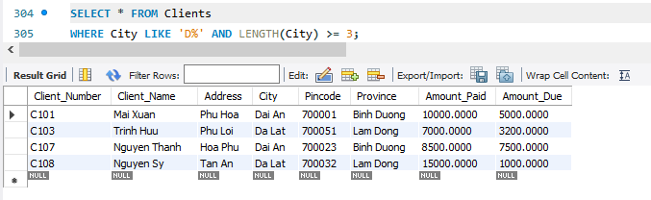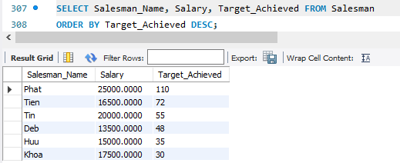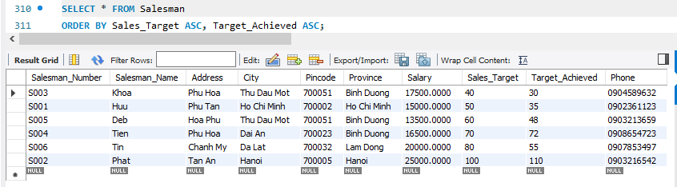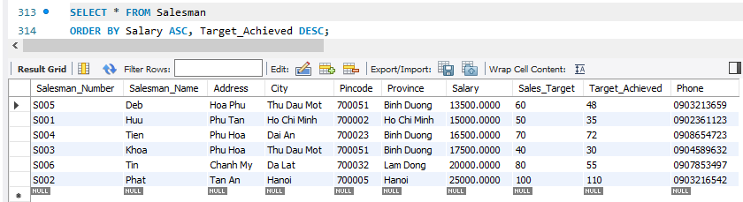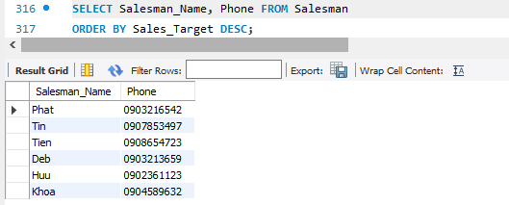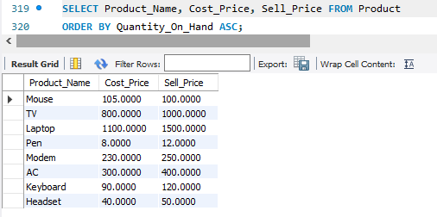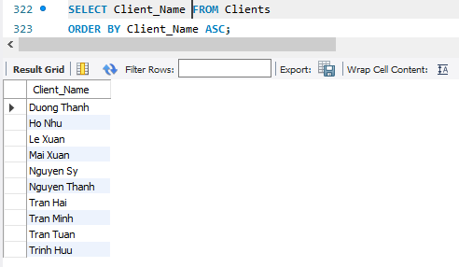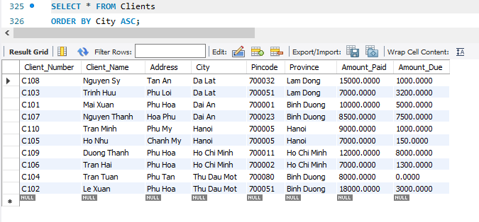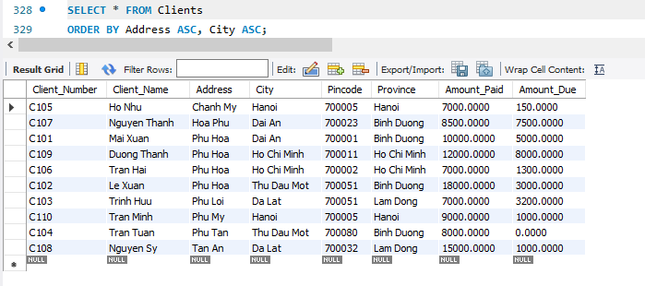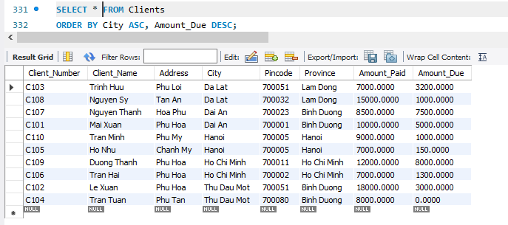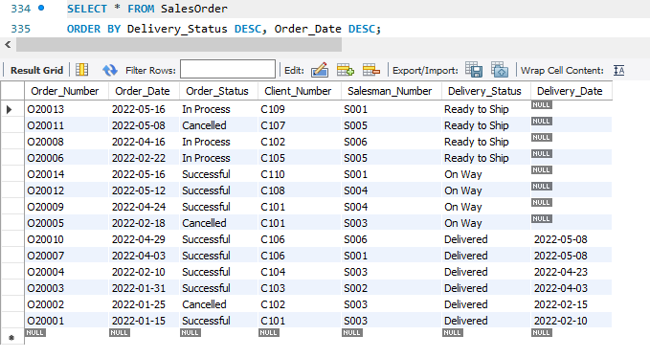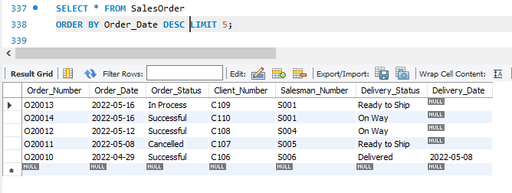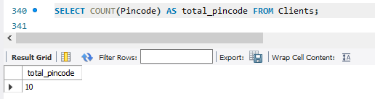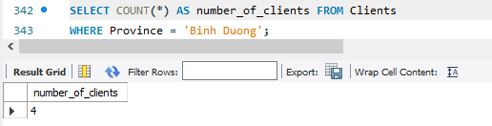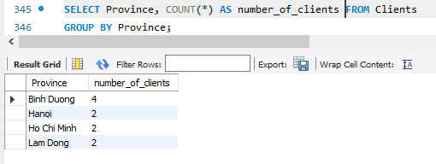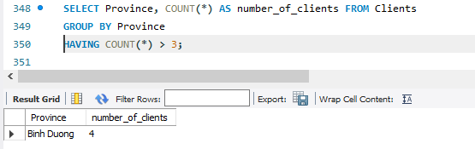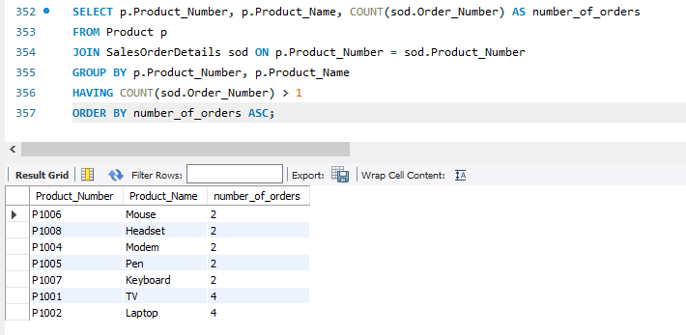

Sources:

create database SaleManagerment;
use SaleManagerment;

create table Clients (
Client_Number varchar(10),
Client_Name varchar(25) not null,
Address varchar(30),
City varchar(30),
Pincode int not null,
Province char(25),
Amount_Paid decimal(15, 4),
Amount_Due decimal(15, 4),

primary key (Client_Number),

check (Client_Number like 'C%')
);

create table Product (
Product_Number varchar(15),
Product_Name varchar(25) not null unique,
Quantity_On_Hand int not null,
Quantity_Sell int not null,
Sell_Price decimal(15, 4) not null,
Cost_Price decimal(15, 4) not null,

primary key (Product_Number),

check (Product_Number like 'P%'),
check (Cost_Price <> 0)
);

create table Salesman (
Salesman_Number varchar(15),
Salesman_Name varchar(25) not null,
Address varchar(30),
City VARCHAR(30),
Pincode int not null,
Province char(25) DEFAULT('Viet Nam'),
Salary DECIMAL(15, 4) not null,
Sales_Target int not null,
Target_Achieved int,
Phone char(10) not null unique,

PRIMARY KEY (Salesman_Number),

CHECK (Salesman_Number like 'S%'),
check (Salary <> 0),
check (Sales_Target <> 0)
);

create table SalesOrder (
Order_Number varchar(15),
Order_Date date,
Order_Status varchar(15),
Client_Number VARCHAR(15),
Salesman_Number varchar(15),
Delivery_Status char(15),
Delivery_Date date,

PRIMARY KEY (Order_Number),
FOREIGN KEY (Client_Number) REFERENCES clients(Client_Number),
FOREIGN KEY (Salesman_Number) REFERENCES salesman(Salesman_Number),

CHECK (Order_Number like 'O%'),
check (Client_Number like 'C%'),
check (Salesman_Number like 'S%'),
check (Delivery_Date > Order_Date),
check (Delivery_Status in ('Delivered', 'On Way', 'Ready to Ship')),
check (Order_Status in ('In Process', 'Successful', 'Cancelled'))
);

drop table SalesOrderDetails;
create table SalesOrderDetails (
Order_Number varchar(15),
Product_Number varchar(15),
Order_Quantity int,
Discount_Rate int,

FOREIGN KEY (Order_Number) REFERENCES salesorder(Order_Number),
FOREIGN KEY (Product_Number) REFERENCES product(Product_Number),

check (order_number like 'O%'),
check (product_number like 'P%')
);

insert into clients(Client_Number, Client_Name, Address, City, Pincode, Province, Amount_Paid, Amount_Due)
VALUES
('C101','Mai Xuan','Phu Hoa','Dai An',700001,'Binh Duong',10000,5000),
('C102','Le Xuan','Phu Hoa','Thu Dau Mot',700051,'Binh Duong',18000,3000),
('C103','Trinh Huu','Phu Loi','Da Lat',700051,'Lam Dong ',7000,3200),
('C104','Tran Tuan','Phu Tan','Thu Dau Mot',700080,'Binh Duong',8000,0),
('C105','Ho Nhu','Chanh My','Hanoi',700005,'Hanoi',7000,150),
('C106','Tran Hai','Phu Hoa','Ho Chi Minh',700002,'Ho Chi Minh',7000,1300),
('C107','Nguyen Thanh ','Hoa Phu','Dai An',700023,'Binh Duong',8500,7500),
('C108','Nguyen Sy','Tan An','Da Lat',700032,'Lam Dong ',15000,1000),
('C109','Duong Thanh','Phu Hoa','Ho Chi Minh',700011,'Ho Chi Minh',12000,8000),
('C110','Tran Minh','Phu My','Hanoi',700005,'Hanoi',9000,1000);

insert into product(Product_Number, Product_Name, Quantity_On_Hand, Quantity_Sell, Sell_Price, Cost_Price)
VALUES
('P1001','TV',10,30,1000,800),
('P1002','Laptop',12,25,1500,1100),
('P1003','AC',23,10,400,300),
('P1004','Modem',22,16,250,230),
('P1005','Pen',19,13,12,8),
('P1006','Mouse',5,10,100,105),
('P1007','Keyboard',45,60,120,90),
('P1008','Headset',63,75,50,40);

INSERT into salesman(Salesman_Number, Salesman_Name, Address, City, Pincode, Province, Salary, Sales_Target, Target_AchieveD, Phone)
VALUES
('S001','Huu','Phu Tan','Ho Chi Minh',700002,'Ho Chi Minh',15000,50,35,'0902361123'),
('S002','Phat','Tan An','Hanoi',700005,'Hanoi',25000,100,110,'0903216542'),
('S003','Khoa','Phu Hoa','Thu Dau Mot',700051,'Binh Duong',17500,40,30,'0904589632'),
('S004','Tien','Phu Hoa','Dai An',700023,'Binh Duong',16500,70,72,'0908654723'),
('S005','Deb','Hoa Phu','Thu Dau Mot',700051,'Binh Duong',13500,60,48,'0903213659'),
('S006','Tin','Chanh My','Da Lat',700032,'Lam Dong',20000,80,55,'0907853497');

INSERT into Salesorder(Order_Number, Order_Date, Client_Number, Salesman_Number, DeliveRy_Status, Delivery_Date, Order_Status)
VALUES
('O20001','2022-01-15','C101','S003','Delivered','2022-02-10','Successful'),
('O20002','2022-01-25','C102','S003','Delivered','2022-02-15','Cancelled'),
('O20003','2022-01-31','C103','S002','Delivered','2022-04-03','Successful'),
('O20004','2022-02-10','C104','S003','Delivered','2022-04-23','Successful'),
('O20005','2022-02-18','C101','S003','On Way',null,'Cancelled'),
('O20006','2022-02-22','C105','S005','Ready to Ship',null,'In Process'),
('O20007','2022-04-03','C106','S001','Delivered','2022-05-08','Successful'),
('O20008','2022-04-16','C102','S006','Ready to Ship',null,'In Process'),
('O20009','2022-04-24','C101','S004','On Way',null,'Successful'),
('O20010','2022-04-29','C106','S006','Delivered','2022-05-08','Successful'),
('O20011','2022-05-08','C107','S005','Ready to Ship',null,'Cancelled'),
('O20012','2022-05-12','C108','S004','On Way',null,'Successful'),
('O20013','2022-05-16','C109','S001','Ready to Ship',null,'In Process'),
('O20014','2022-05-16','C110','S001','On Way',null,'Successful');

iNSERT Into salesorderdetails(Order_Number, Product_Number, Order_Quantity)
VALUES
('O20001','P1001',5),
('O20001','P1002',4),
('O20002','P1007',10),
('O20003','P1003',12),
('O20004','P1004',3),
('O20005','P1001',8),
('O20005','P1008',15),
('O20005','P1002',14),
('O20006','P1002',5),
('O20007','P1005',6),
('O20008','P1004',8),
('O20009','P1008',2),
('O20010','P1006',11),
('O20010','P1001',9),
('O20011','P1007',6),
('O20012','P1005',3),
('O20012','P1001',2),
('O20013','P1006',10),
('O20014','P1002',20);

DESCRIBE Clients;
DESCRIBE Product;
DESCRIBE Salesman;
DESCRIBE SalesOrder;
DESCRIBE SalesOrderDetails;

Select * from clients;
Select * from Product;
Select * from Salesman;
Select * from SalesOrder;
Select * from SalesOrderDetails;

Select * from clients
where province = 'Binh Duong';

Select Client_Name, Client_Name from clients
where not province = 'Hanoi';

select product_name from product
where quantity_on_hand < 25;

select product_name from product
where sell_price < cost_price;

select * from salesman
where sales_target > target_achieved;

select Salesman_Name, City from Salesman
where salary < 10000 or salary > 17000;

select Order_Date, Client_Number from SalesOrder
where order_date between '2022-01-01' and '2022-02-15';

select city from clients
where city like 'N%';

select * from clients
where Client_Name like '__u%';

select * from clients
where Client_Name like '%u_';

select city from clients
where city like 'D%' and city like '%n';

select * from clients
where city in ('Ho Chi Minh', 'Hanoi', 'Da Lat');

select * from clients
where not city in ('Ho Chi Minh', 'Hanoi', 'Da Lat');

select AVG(salary) as salary_average from salesman;

select Salesman_Name from Salesman
where salary = (select max(salary) from salesman);

select Salesman_Name from salesman
where salary = (select min(salary) from salesman);

select count(*) as total_salespeople from salesman;

select sum(salary) as total_salary from salesman;

select * from salesman
order by salary ASC;

select salesman_name, phone from salesman
order by target_achieved ASC, city DESC;

select salesman_name from salesman
order by salesman_name DESC limit 3;

select salary, salesman_name from salesman
order by salary DESC limit 1;

select salary, salesman_name from salesman
order by salary ASC limit 2;

select * from salesorder
order by order_number ASC Limit 5;

select * from salesorder
order by order_number ASC Limit 15 OFFSET 5;

select province, count(*) as number_of_clients from clients
group by province
having count(*) > 1
order by number_of_clients DESC;

select Clients.* from clients
join salesorder on Clients.client_number = salesorder.client_number
group by Clients.client_number
having count(salesorder.order_number) > 1;

Select Client_Name, Amount_Due from Clients
Where city = 'Hanoi';

SELECT * FROM Clients
WHERE Amount_Due > 3000;

SELECT Client_Name, Province FROM Clients
WHERE Amount_Due = 0;

SELECT * FROM Clients
WHERE Amount_Paid BETWEEN 10000 AND 13000;

SELECT * FROM Clients
WHERE Client_Name = 'Dat';

SELECT Product_Name, Sell_Price FROM Product;

SELECT Quantity_On_Hand FROM Product
WHERE Product_Name = 'TV';

SELECT * FROM Salesman
WHERE Target_Achieved < Sales_Target;

SELECT * FROM Product
WHERE Product_Number = 'P1005';

SELECT Cost_Price, Sell_Price FROM Product
WHERE Product_Name = 'Mouse';

SELECT Salesman_Name, Phone FROM Salesman
WHERE City = 'Thu Dau Mot';

SELECT Salesman_Name, Salary FROM Salesman;

SELECT Salesman_Name, Salary FROM Salesman
WHERE Salary BETWEEN 10000 AND 17000;

SELECT * FROM Salesman
WHERE Salary BETWEEN 10000 AND 20000 AND Target_Achieved >= Sales_Target;

SELECT * FROM Salesman
WHERE Salary BETWEEN 20000 AND 30000 AND Target_Achieved < Sales_Target;

SELECT * FROM Clients
WHERE Client_Name NOT LIKE '%h';

SELECT Client_Name FROM Clients
WHERE Client_Name LIKE '_r%' OR Client_Name LIKE '%a_';

SELECT * FROM Clients
WHERE City LIKE 'D%' AND LENGTH(City) >= 3;

SELECT Salesman_Name, Salary, Target_Achieved FROM Salesman
ORDER BY Target_Achieved DESC;

SELECT * FROM Salesman
ORDER BY Sales_Target ASC, Target_Achieved ASC;

SELECT * FROM Salesman
ORDER BY Salary ASC, Target_Achieved DESC;

SELECT Salesman_Name, Phone FROM Salesman
ORDER BY Sales_Target DESC;

SELECT Product_Name, Cost_Price, Sell_Price FROM Product
ORDER BY Quantity_On_Hand ASC;

SELECT Client_Name FROM Clients
ORDER BY Client_Name ASC;

SELECT * FROM Clients
ORDER BY City ASC;

SELECT * FROM Clients
ORDER BY Address ASC, City ASC;

SELECT * FROM Clients
ORDER BY City ASC, Amount_Due DESC;

SELECT * FROM SalesOrder
ORDER BY Delivery_Status DESC, Order_Date DESC;

SELECT * FROM SalesOrder
ORDER BY Order_Date DESC LIMIT 5;

SELECT COUNT(Pincode) AS total_pincode FROM Clients;

SELECT COUNT(*) AS number_of_clients FROM Clients
WHERE Province = 'Binh Duong';

SELECT Province, COUNT(*) AS number_of_clients FROM Clients
GROUP BY Province;

SELECT Province, COUNT(*) AS number_of_clients FROM Clients
GROUP BY Province
HAVING COUNT(*) > 3;

SELECT p.Product_Number, p.Product_Name, COUNT(sod.Order_Number) AS number_of_orders
FROM Product p
JOIN SalesOrderDetails sod ON p.Product_Number = sod.Product_Number
GROUP BY p.Product_Number, p.Product_Name
HAVING COUNT(sod.Order_Number) > 1
ORDER BY number_of_orders ASC;

